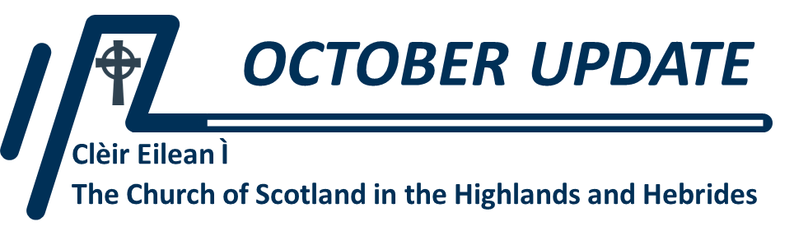

***News from* *Clèir Eilean Ì Transition Team***

**SALANN IS SOLAS… SALT AND LIGHT…**

As a registered Scottish Charity (OSCR number SC001424) CEI has drafted its Business Plan. The opening paragraph summarises what we’re all about:

***Clèir Eilean Ì* is the fruit of four years of prayerful planning to reform *The Church of Scotland in the Highlands & Hebrides*. Our priority is to refresh mission and ministry through local churches by applying resources and developing resourcefulness. The scale and variety of our landscape argues for creativity and imagination, while the resurgence of Gaelic culture presents a special opportunity, especially because of the deep and fruitful links between the Gaelic language and Christian mission. Reducing the burden of administration and transforming all of our buildings into well-equipped spaces in the right places will free local congregations to concentrate on being salt and light alongside fellow Christians in neighbouring churches and denominations…**

**WHERE WE ARE:**

Rory MacLeod officially takes up his appointment as our first Presbytery Clerk on 1st November – but has already begun meeting key people, from our nine existing Clerks to Central Services and other “big presbytery” colleagues, providing everything from HR and IT assistance and advice to other service providers like Sanctus Media, now engaged in developing our website.

This will become a key part of how Clèir Eilean Ì communicates – not just with the outside world but within the Presbytery itself: facilitating committee work, the development of mission “hubs” and becoming a central resource for all. As the Business Plan puts it:

***On account of the dwindling availability of Ministers of Word and Sacrament (121 MWS currently serving 123 charges reducing to 70 MWS serving 110 charges), either parishes will have to expand and churches become even more remote from the communities they serve, or new ways of delivering mission and ministry will need to be conceived. These might involve investing in areas of strength and potential, through a mixture of chaplaincy and more traditional models of ministry, while cultivating the gifts of the whole people of God, recruiting and training lay volunteers, identifying candidates for ministry apprenticeships and developing partnerships and projects with other churches and denominations...***

**WHAT’S NEXT?**

We’re hoping to be able to announce our Moderator designate in November. Meanwhile, our embryo committees are all now beginning to meet – a process that is already introducing innovation. As an example, our Mission and Ministry Support Committees have started to meet together and it may be that the result is three, rather than one or two, working committees, each with a clear focus on their task: ministry, mission planning, plan implementation.

We’re aiming to have our website go “live” well ahead of the Presbytery’s launch – we’ll send everyone the link – and we’re planning that the next edition of this monthly Update will reach you by two different routes: one from your existing Clerk, and one from Rory as CEI Clerk. This should allow us to check that everyone who’ll be a member of CEI is on our database. Those who only get one Update can confirm which route didn’t work, and enable us to sort it in good time. And our Roadshow programme continues; by the time you read this, Doug McRoberts and/or Rory MacLeod will have met with Argyll, Inverness, Lochcarron-Skye, Lochaber, and Sutherland Presbyteries on behalf of the CEI Transition Team. Five down, four to go… (We were also invited to share the presentation with our neighbours in Lewis.)

**PRAYER POINTS**

**Give thanks…**

…in this season of Remembrance, for those whose lives have been given in Christ’s service.

…for work now underway to build our infrastructure, and our vital communications, both inward and outward facing.

…for the faithful service and witness of our nine Presbytery Clerks, and their predecessors.

**Ask…**

…for the healing and recuperation of Donald, our new Business Committee Convener.

…that the work of our embryo committees be blessed, inspired, and given vision.

…for God’s guidance in the development of our website and communications infrastructure.

…that God’s call to our first Moderator will soon be confirmed.

**AND FINALLY…** as the draft Business Plan puts it in its Conclusion:

***Clèir Eilean Ì* unites nine existing presbyteries covering most of the Highlands & Hebrides. For a fraction of the cost which might have been required for several smaller presbyteries, *Clèir Eilean Ì* will manifest the *Church of Scotland in the Highlands & Hebrides* and, in partnership with our friends and neighbours in other denominations, will be and will proclaim the *Good News of Jesus* in culturally sensitive and missionally creative ways through a territorial ministry covering the entire region. During the course of the first five years of its existence it will sow resourcefulness and expertise into local churches to the extent that they will grow into a network of self-sustaining and self-perpetuating local churches.**

***Beannachdan san ràith cuimhneachaidh seo –***

***Blessings in this season of remembering.***